Journal: Ecology
Article Title: Interpreting field measurements of juvenile growth and survival rates with population growth isoclines
Authors: Nathan T. Barrus, Mark I. Cook & Nathan J. Dorn.

Appendix S1: Isocline Development

We used a published stage-structured model called EVERSNAIL (Darby et al., 2015) (hereafter referred to as ‘the population model’) to identify juvenile survival and developmental rate parameters that are expected to produce growing populations of apple snails. The population model was created to project population size across the extent of the Everglades and includes local scale sub-models that parameterize life history (i.e., survival, developmental rates, and reproduction). Depth and temperature data used in the population model from the Everglades was provided from the Everglades Depth Estimation Network (EDEN; Jones, 2015) and South Florida Water Management Districts online database (DBHydro; www.sfwmd.gov/science-data/dbhydro), respectively. The population model was built with the best available understanding of the Florida Apple Snail life history and includes life history responses to hydrologic variation. The model projects age- and size- structure on a daily time step using matrices (a.k.a. Leslie Matrix). The structure of the matrices are based on size which are indexed using a growth at age equation. Survival and fecundity rates within the transition matrix are size-dependent. The transition matrix and structure matrix are given below:
and $N =\left|\begin{matrix}\begin{matrix}N_{1} \\ N_{2} \\ N_{3}\end{matrix} \\ \begin{matrix}. \\ N_{i} \\ N_{i+1}\end{matrix} \\ \begin{matrix}N_{i+2} \\ . \\ \begin{matrix}N_{499} \\ N_{500}\end{matrix}\end{matrix}\end{matrix}\right|$
Where A is the transition matrix from one daily step to another, N is population vector based on age. a_{i,j} are the age specific daily survival probabilities, and f_{i} are the age specific fecundity rates. These matrices provide the age index for the population size structure which is determined by the following size at age equation.
Size_{min} = linear size of newly hatched snail, Size_{max} = maximum size of snail, and k_{growth} = daily growth rate. Survival during hydrological droughts and depth-dependent reproduction tie the model to hydrologic variation (Darby et al., 2015). For further details see the appendix in Darby et al., (2015).
We wanted to use the model to examine individual juvenile stage parameters and at a local scale, so we re-coded the population model for research in R version 4.0.3 using the parameter details found in the supplement (Darby et al., 2015). While most of the parameters were left as described by the original model (Table S1.1), two parameters were altered. First, the number of egg masses produced per female was changed by standardizing reproductive effort across the life span of a female snail. A maximum number of egg masses that a female can produce was discussed in a large unpublished review of apple snail ecology (Pomacea Project, 2013); to standardize reproductive output, the population model’s current parameter (Mass Size) was multiplied by the maximum number of egg masses a female can lay and then divided by the life span of the female (500 days in the model). Second, we removed the carrying capacity from the model to examine what parameter values allow the population to increase.
Four parameters were used to model developmental rates and juvenile survival. Developmental rates were determined by the parameter k_{growth} and assumes size- dependence. The initial parameter estimate for k_{growth} in the population model was 0.05. There were three parameters (Surv₁, Surv₂ and Surv₃) that determined juvenile survival during wet condition and were based on size classes (Surv₁ = 3-6 mm, Surv₂= 6-10 mm, Surv₃ = 10-16 mm SL). A fourth rate was used for large juvenile and adult snails (Surv₄ > 16 mm SL). Under the parameters in the population model, survival through the juvenile stage (3-16 mm SL) was constantly high (98.7% · day⁻¹). Survival slightly increased after snails reached 16 mm SL (99.0% · day⁻¹) and remained constant until the snails reached 500 days when survival declined to 0 reflecting adult senescence (Hanning, 1979). Alternate survival parameters were included in the population model for conditions of hydrological drought (dry sediment surfaces in the dry season), but the drought parameters were not important for our simulations.
To determine growth and survival parameters that controlled population growth, we calculated population growth through combinatorial re-assessments with different values under two different hydrologic regimes. We chose the wet condition parameters for survival to make the simulations most representative of the sloughs in the ridge-slough landscape. Before we started simulations aimed at varying developmental rate and survival parameters under different hydrologic regimes, we obtained an initial population size with a stable size structure. We ran the model using the model’s original developmental rate and survival parameters for ten years of repeated depth and temperature data (January 1st to December 31st, 2020). The hydrologic data was taken from DBHYDRO’s depth transponder in LILA’s wetland M2, and the air temperature data was taken from the transponder nearest to LILA in West Palm Beach, FL (transponder coordinates: 26.6548⁰N, 80.0669⁰W). We tested differences between three starting hatchling numbers (100, 1000, and 10000 hatchlings), but starting numbers did not influence population growth.
Following this 10-year simulation to establish a stable size structure, we introduced two different hydrologic regimes repeated for 5 years that varied in depth-dependent egg-laying conditions. First, we used the poor reproduction hydrologic conditions from LILA that was deeper in the wet season of 2020 (Figure 2A). Next, (2) we used the good reproduction conditions (Figure 2A). The model runs with poor and good reproduction hydrographs were both conducted using natural temperature regimes taken from West Palm Beach, FL (Appendix 1).
Under each hydrological regime, simulations were conducted under different combinations of the parameters k_{growth}, Surv₁, and Surv₂. k_{growth} values were allowed to vary from 0.01 to 0.09 using increments of 0.005 and the two small juvenile survival parameters for wet conditions were decreased by 5%, 10% 15%, 20%, 30% and 40% of the starting values (0.987 day⁻¹). Simulations were run under all combinations of the variations in the three parameters (n_{simulations} = 833 per hydrologic regime). The population size on every simulated February 1st was taken to calculate an annual population growth rate (e.g., λ_{i} = N_{i}/N_{i+1}; where i = year). February 1st was used because it corresponded to the day when the population model initiates the reproductive season. The geometric mean of the annual population growth rates over 5 years was taken to obtain a λ_{avg}. The intrinsic rate of increase (r) was then calculated by taking the natural logarithm of λ_{avg}. When r = 0 a population is at replacement, when r < 0 a population is declining, and when r > 0 a population is increasing.
The results of the simulations were used to identify combinations of development rates and survival of juveniles that determined thresholds (r = 0) for population growth given the two hydrologic regimes. Although the simulations were conducted with individualized parameters for the two size classes, we reduced dimensionality to aid in interpretation by multiplying the two juvenile survival probabilities which we named cumulative juvenile survival (i.e., survival < 10 mm SL = CJS; Figure 1A). At each level of k_{growth}, the intrinsic rate of increase (r) was regressed (Ordinary Least Squared-OLS) as a function of CJS, then the regression equation was used to solve for the CJS for which r = 0. The combinations of individual growth (k_{growth}) and juvenile survival (CJS) were plotted as zero population-growth isoclines (Figure 2B).

Table S1: List of parameters from EVERSNAIL, their values, the vital rate function they influence, what the function’s purpose is in the population model, the adjusted parameters, and short description of the altered parameters.
Parameter | Value | Vital Rate F(x)n | F(x)n purpose | Adjustment | How
Size_{min} | 3 mm | Growth 1 | Model individual growth | No
Size_{max} | 50 mm | Growth 1 | Model individual growth | No
k_{growth} | 0.05 | Growth 1 | Model individual growth | Alter | Explore values (0.01-0.09) and measure in the field
Surv₁ (3-6mm) | 0.987 day⁻¹ | Survival 1 | Model size-dependent survival under wet conditions | Alter | Explore decreases of 5%-40% and measure in the field
Surv₂ (6-10mm) | 0.987 day⁻¹ | Survival 1 | Model size-dependent survival under wet conditions | Alter | Explore decreases of 5%-40% and measure in the field
Surv₃ (10-16mm) | 0.987 day⁻¹ | Survival 1 | Model size-dependent survival under wet conditions | No
Surv₄ (>16mm) | 0.99 day⁻¹ | Survival 1 | Model size-dependent survival under wet conditions | No
Surv_{drought1} | 0.976 day⁻¹ | Survival 2 | Model size-dependent survival under dry conditions | No
Surv_{drought2} | 0.984 day⁻¹ | Survival 2 | Model size-dependent survival under dry conditions | No
Surv_{drought3} | 0.989 day ⁻¹ | Survival 2 | Model size-dependent survival under dry conditions | No
Surv_{drought4} | 0.99 day⁻¹ | Survival 2 | Model size-dependent survival under dry conditions | No
Age_{mort} | 500 days | Survival 3 | Induce rapid die off of adults after 1.5 years old | No
k_{age} | 0.1 day⁻¹ | Survival 3 | Induce rapid die off of adults after 1.5 years old | No
Mortality Threshold | 27.5 mm | Survival 3 | Induce rapid die off of adults after 1.5 years old | No
Egg Mass Size | 30 eggs | Reproduction 1 | Give a measure of fecundity | Change | Standardize to eggs produced per female
k_{repr} | 1 | Reproduction 2 | Model the relationship between fecundity and water depth | No
Depth_{mid} | 50 cm | Reproduction 2 | Model the relationship between fecundity and water depth | No
W_{k} | 40 | Reproduction 2 | Model the relationship between fecundity and water depth | No
Depth_{min} | 10 cm | Reproduction 2 | Model the relationship between fecundity and water depth | No
Depth_{max} | 90 cm | Reproduction 2 | Model the relationship between fecundity and water depth | No
k_{temp} | 1 degree C⁻¹ | Reproduction 3 | Model the relationship between fecundity and temperature | No
Temperature Threshold | 17 degree C | Reproduction 3 | Model the relationship between fecundity and temperature | No
Female | 0.5 | Reproduction 4 | Females alone can lay eggs | No
Peak Reproduction | 1 (Feb-June) | Reproduction 5 | Model seasonal effects on fecundity | No
Minor Reproduction | 0.3 (June-Sep) | Reproduction 5 | Model seasonal effects on fecundity | No
No Reproduction | 0 (Sep-Feb) | Reproduction 5 | Model seasonal effects on fecundity | No
Carrying Capacity | 35000 egg masss ha⁻¹ | Reproduction 6 | Provides density dependence so the population cannot grow towards infinity | Remove | Explore threshold of increasing and decreasing populations

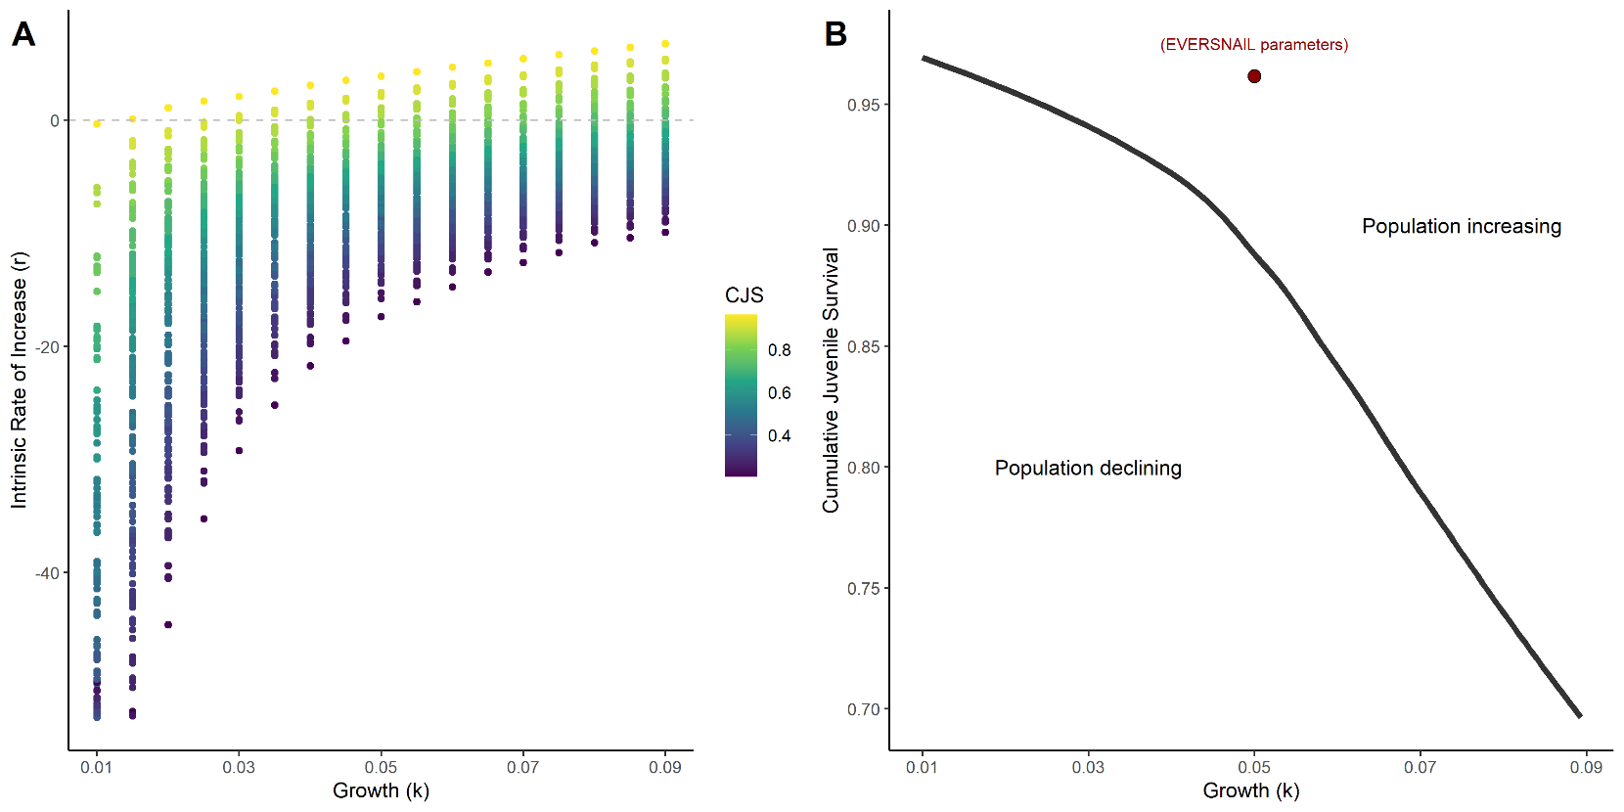
Figure S1: Scatterplot showing the intrinsic rate of increase (r) as a function of k_{growth} and Cumulative Juvenile Survival (CJS) from all simulations. The dashed line indicates an r = 0 which means populations are at replacement (i.e., not increasing nor declining).
Maximizing reproduction for isocline
To determine if maximizing reproduction could shift population growth to increasing, we created an isocline under constant depth and temperature conditions that maximizes reproductive effort.
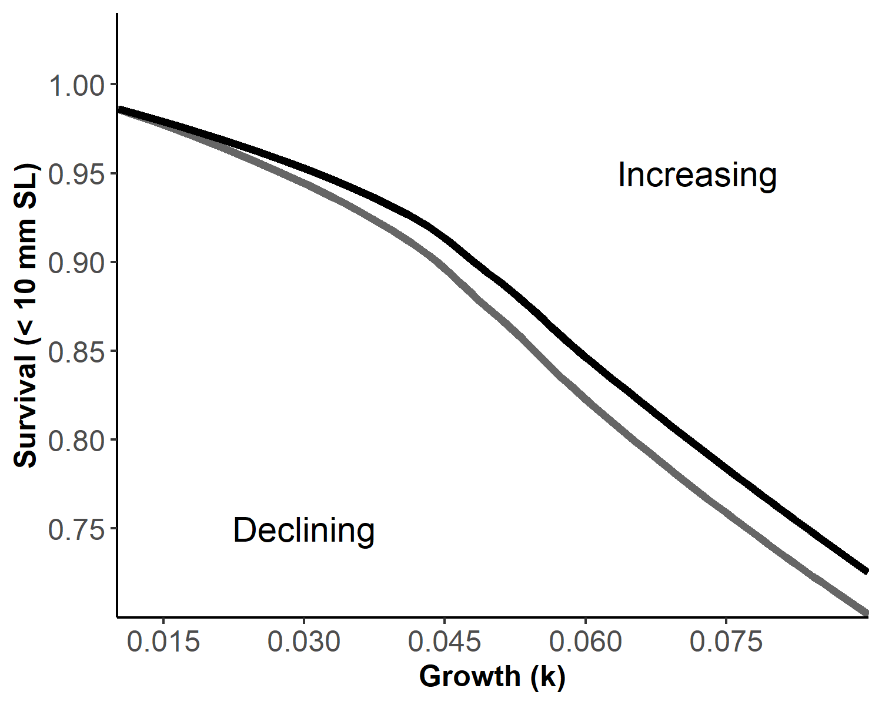
Figure S2: Isoclines illustrating the bivariate effects of juvenile growth and survival that produce zero net annual population growth for a size-structured model of a freshwater gastropod (Pomacea paludosa) under different hydrologic regimes that affect reproduction. The black isocline and gray isoclines represent three hydrologic scenarios producing maximized natural better (Dark Grey) and natural worse (Black) reproductive conditions. Better hydrologic conditions shift the isocline down and to the left enabling populations to withstand lower survival and slower growth.
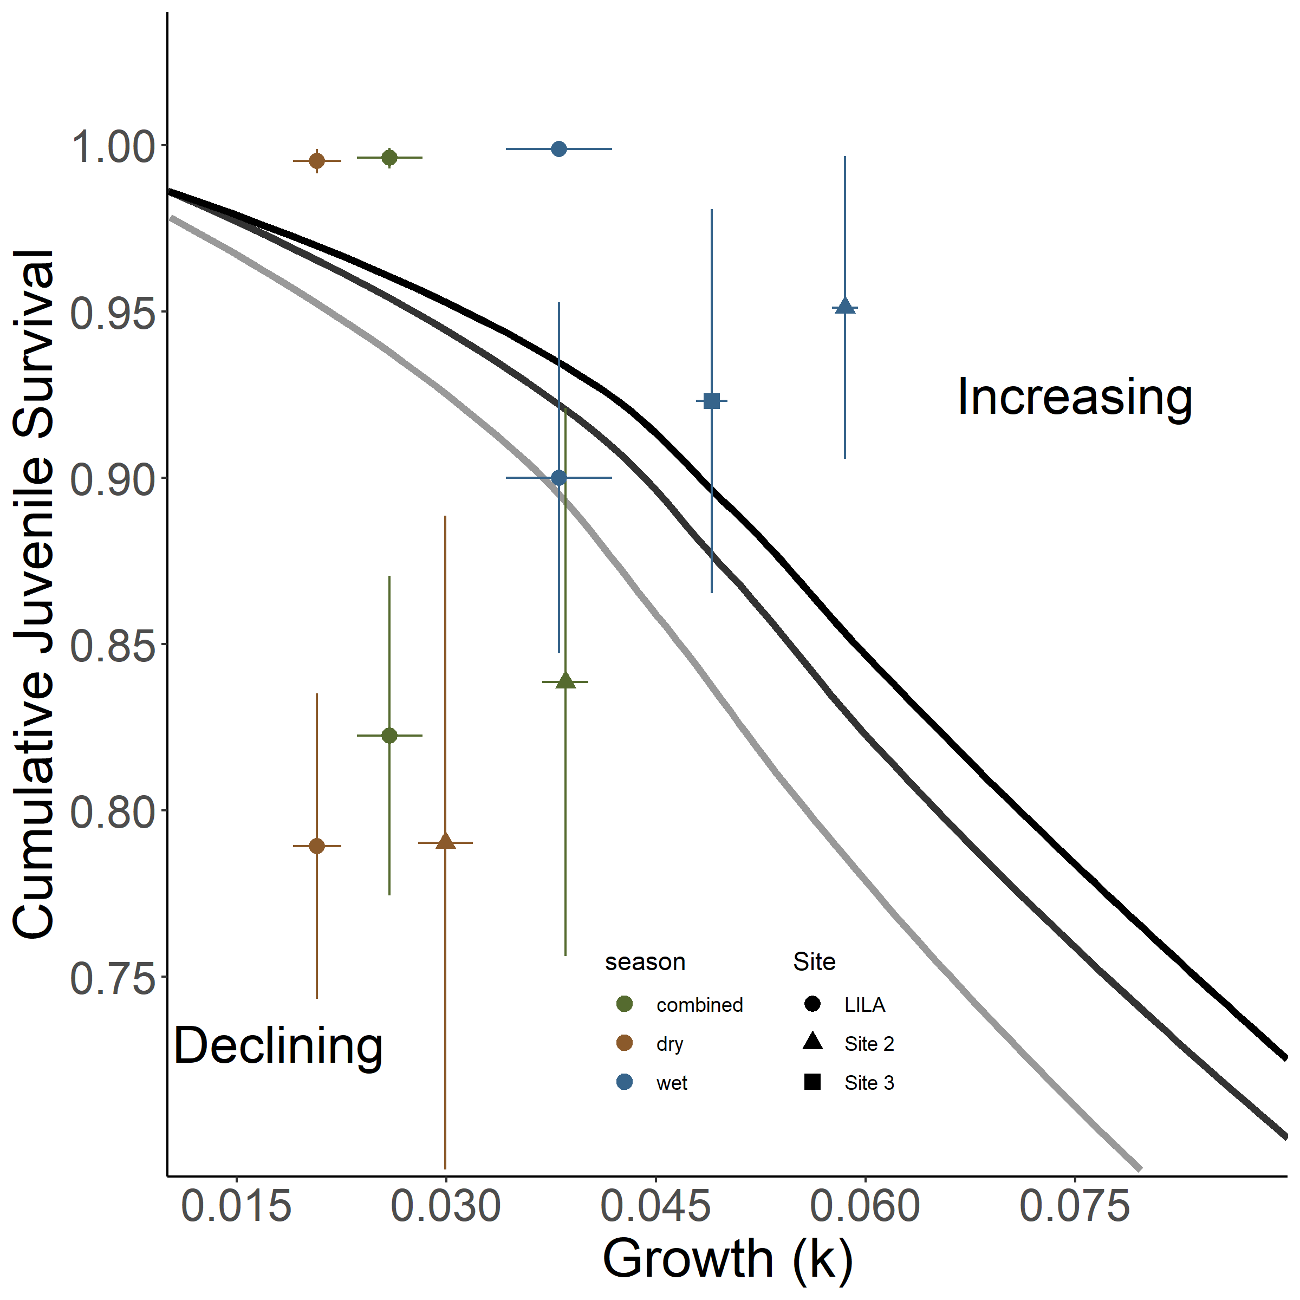
Figure S3: Isoclines illustrating the bivariate effects of juvenile growth and survival that produce zero net annual population growth for a size-structured model of a freshwater gastropod (Pomacea paludosa) under different hydrologic regimes that affect reproduction. The black isocline and gray isoclines represent three hydrologic scenarios producing maximized (Light Grey) natural better (Dark Grey) and natural worse (Black) reproductive conditions. Mean survival (snails < 10mm SL) and growth (k_{growth}) quantified in LILA and WCA3A are plotted on each panel with seasonal and combined parameters. The combined parameters were calculated by a weighted average reflecting greater juvenile snail production in the dry season.
References
Barrus, N. T., Drumheller, D., Cook, M. I., & Dorn, N. J. (2023). Life history responses of two co-occurring congeneric Apple Snails (Pomacea maculata and P. paludosa) to variation in water depth and metaphyton total phosphorus. Hydrobiologia.
Darby, P. C., DeAngelis, D. L., Romañach, S. S., Suir, K., & Bridevaux, J. (2015). Modeling apple snail population dynamics on the Everglades landscape. Landscape Ecology, 30(8), 1497–1510. https://doi.org/10.1007/s10980-015-0205-5
Jones, J. W. (2015). Efficient wetland surface water detection and monitoring via landsat: Comparison with in situ data from the everglades depth estimation network. Remote Sensing, 7(9), 12503–12538. https://doi.org/10.3390/rs70912503
Pomacea Project, Inc. (2013). Literature Review of Florida Apple Snails and Snail Kites , and Recommendations for their Adaptive Management. Final.Report Submitted to National Park Service, Everglades National Park, by The Pomacea Project, Inc., Pensacola, Florida.

